WHICH CORRECTION stem question Station DIRECTIONS

10 minutes: answer the questions

1. To answer these types of questions, you should write in the changes in the sentence (the first one has been done for you).
2. Then, you should read (or mouth) the sentence out loud with those changes.
3. Make sure you read all the answer choices
4. Eliminate which you know are wrong and then decide on the best answer.

5 minutes: trade and check your answers

1. When there are only five minutes left in the station, mix the papers up among your group.
2. Get an answer key. Go through and grade your classmates paper, marking the correct answer when needed.
3. Figure out WHY you missed the questions you did.
4. 1 point= each question correct. Total points=# of questions tried

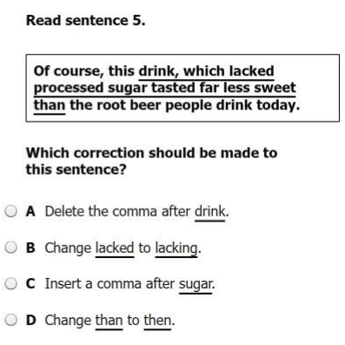

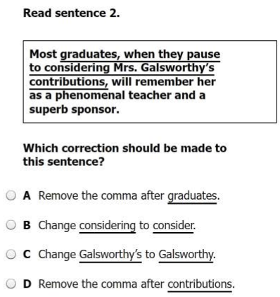

These questions are different. There are SMALL changes in each of the sentences. To answer these questions, circle what is different in each question and then go through and answer. The first has been done for you.



