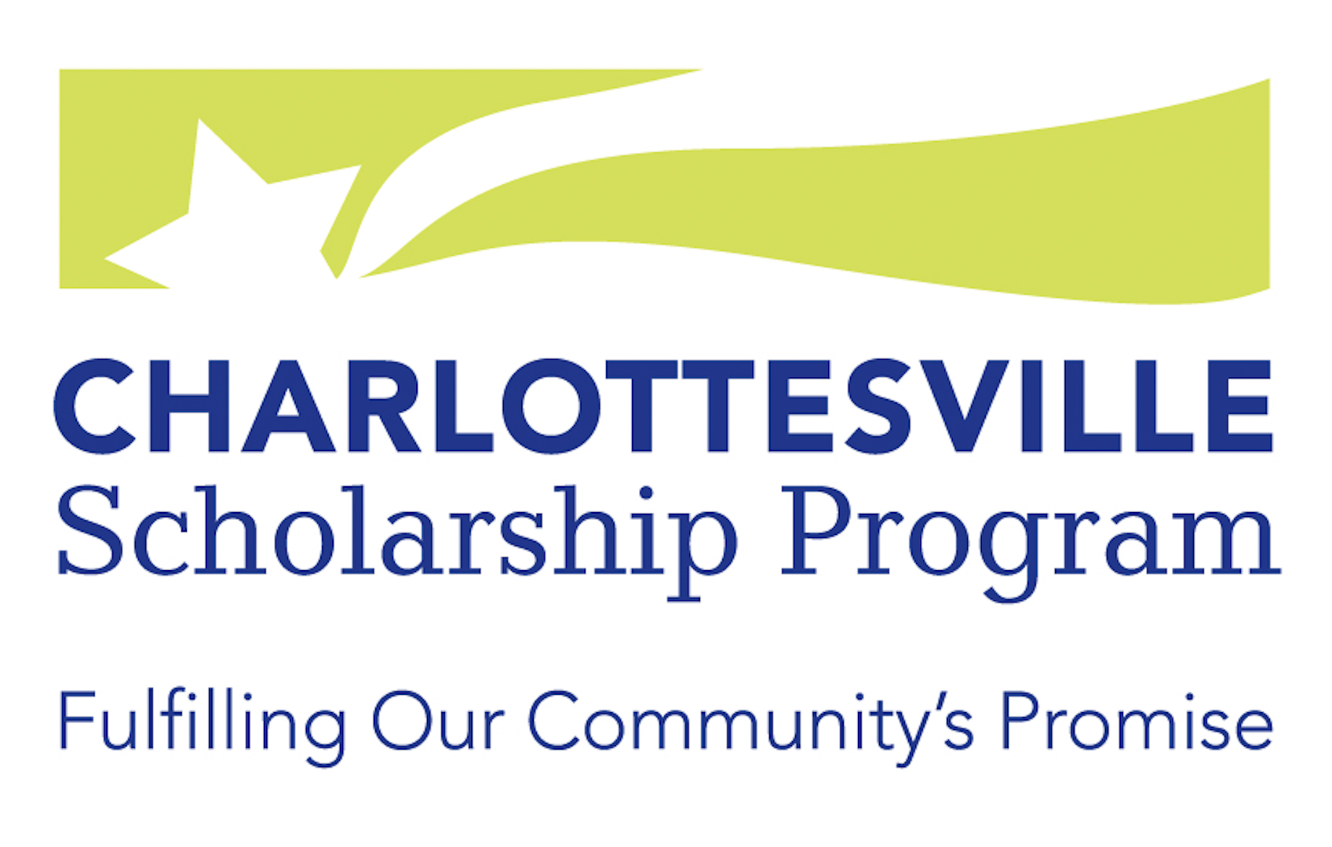

Charlottesville Promise and Preston Coiner Scholarships

Application Information

The Charlottesville Scholarship Program (CSP) accepts applications for Charlottesville Promise Scholarships and Preston Coiner Scholarships once a year. Current college students, adults, and Preston Coiner Scholarship applicants from high schools other than Charlottesville High School must submit applications directly to CSP by March 1st (Postmarked Deadline). CHS seniors may also submit their applications directly to CSP by March 1st. If CHS seniors need assistance completing the application and assembling the required supplemental documentation, they must submit their materials to Ms. Kay Ruffner at the CHS Counseling Center (434-245-2684, ruffnek1@charlottesvilleschools.org) by February 1st.

It is each applicant’s responsibility to submit complete and accurate application packets by the March 1st deadline. Please be sure your name appears on all materials submitted on your behalf. Essays submitted for the Preston Coiner Scholarship should be the applicant’s own work. Incomplete or late applications will not be considered. If you have questions or need assistance in completing the application, please leave a voice message at 434-987-8338 or send an email message to scholars@cvillescholarship.com.

CSP and Preston Coiner Scholarships may be used for tuition, fees, and other school expenses, and students may apply for renewal of the scholarship for each subsequent year of their two- or four-year degree program or technical school certificate program. (See Renewal Instructions on the CSP website.) Recipients are expected to maintain satisfactory academic progress, to remain in regular contact with their assigned Navigator, and to report to the CSP Board of Directors as requested. Scholarship winners must provide the following documentation before scholarship funds can be sent to the college, community college, or technical school the student will be attending:

- Signed Memorandum of Agreement and Acceptance of Scholarship form
- Copy of an official acceptance letter from the accredited two- or four-year college or technical school you will be attending
- College student identification number
- Verification of Enrollment/Pre-Registration form signed by the college registrar
- Completed Student Contact Information form

Equal Opportunity Statement
In accordance with federal law and the law of the Commonwealth of Virginia, the Charlottesville Scholarship Program does not discriminate on the basis of age, race, religion, national origin, sex, sexual orientation, military status or disability.

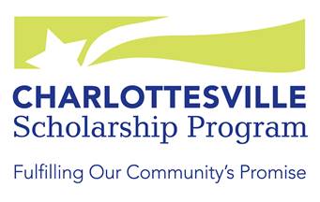

Charlottesville Promise Scholarship
Eligibility Requirements |  | Submission Requirements
Does one of these apply to me?  □ | Be a current CHS graduating senior and a current City  of Charlottesville resident or  Be a CHS graduate and a current City of Charlottesville  resident or  Be a GED recipient of the Charlottesville Public School  System and a current City of Charlottesville resident or  Be a current employee of the City of Charlottesville or  Be current employee of the Charlottesville Public Schools | □ CSP Application—typed or clearly hand-  written in blue or black ink

□ One-page Personal Statement—typed or

clearly hand-written in blue or black ink

□ Be a U.S. citizen or hold a permanent resident visa |  | □ High school, community college, and/or  college Transcripts
□ Be income eligible (see Income Requirements on website) |  | □ Copy of your FAFSA and/or most  recent Federal Income Tax Return of  person who claims you as a dependent
Note: Tuition-paying students at CHS are not eligible  for this scholarship |  | □ Letter of Recommendation from a teacher (if you are a CHS senior) or from a teacher or non-family member who knows you well (if you are an adult)

Application Deadline: March 1st

Preston Coiner Scholarship
Eligibility Requirements |  | Submission Requirements
Does one of these apply to me?  □ | Be a graduating senior of a public or private high school in  the City of Charlottesville or County of Albemarle and  a current City or County resident or  Be a graduate of a public or private high school in  the City of Charlottesville or County of Albemarle and a current City or County resident or  Be an adult who has established residency in the City of  Charlottesville or County of Albemarle regardless of the  high school from which the applicant graduated | □ CSP Application—typed or clearly hand-  written in blue or black ink

□ One-page Personal Statement—typed or

clearly hand-written in blue or black ink

□ An original Essay of 500-1000 words about

Charlottesville or Albemarle County history
□ Be a U.S. citizen or hold a permanent resident visa |  | □ High school, community college, and/or  college Transcripts
□ Be income eligible (see Income Requirements on website) |  | □ Copy of your FAFSA and/or most  recent Federal Income Tax Return of  person who claims you as a dependent
Application Deadline: March 1st |  | □ Letter of Recommendation from a teacher (if you are a CHS senior) or from a teacher or non-family member who knows you well (if you are an adult)
Charlottesville Promise and Preston Coiner Scholarship Application

Type or print legibly in blue or black ink. Please read all directions carefully.
I am applying for: □ Charlottesville Promise Scholarship
□ Preston Coiner Scholarship
□ Both

Name _____________________________________________________________________________
Last First Middle

Permanent Address___________________________________________________________________
Street City State Zip Code

____________________________________________________________________________________________________
Home Telephone Cell Phone Primary Email Address

Date of Birth: _________ High School: ______________________ Year of graduation: _________

List the colleges and/or vocational programs you have applied to: Check if accepted:
_____________________________________________________ □
_____________________________________________________ □
_____________________________________________________ □

Academic/Vocational Interest(s): ________________________________________________________

Attach list of School and Community Activities. (Optional)

List your work experience.

Job Title | Employer | City, State | Dates | Hours Per Week

I certify that the information I have provided on this application and on all supporting documentation is true and complete to the best of my knowledge. If required, I agree to provide proof of this information. If applying for the Preston Coiner Scholarship, I certify that the essay I have submitted is my own original work. I realize that if all required documentation is not submitted by the posted deadline, I will not be considered for a CSP scholarship. If I receive a scholarship, the Charlottesville Scholarship Program may make public my name (and that of my parent(s), guardian(s), or spouse, if applicable), the amount of the scholarship, the school I will be attending, and a brief summary of my qualifications and plans. I also agree to be contacted by CSP representatives as appropriate. This agreement will be in effect as long as I am a scholarship recipient.

_______________________________________ ______________________________
Applicant’s Signature Date

_______________________________________ ______________________________
Parent’s Signature (if applicant is under 18) Date

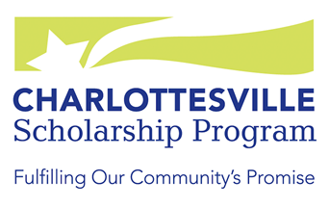
Charlottesville Promise and Preston Coiner Scholarships

Name: _________________________________________

Personal Statement: One-page personal statement that should include your goals for the future, special or unusual circumstances, financial need and/or any other important information you would want the scholarship committee to know. You may use this page or attach a separate statement.

Charlottesville Promise and Preston Coiner Scholarships

Letter of Recommendation

Part 1: To be completed by applicant

Applicant’s Name________________________________ Social Security # _______ (last four digits)

Address______________________________________________________________________________

Telephone____________________ Cell Phone______________ E-mail_________________________

High School _________________________________________ Year Graduated__________________

Program and school in which I plan to enroll________________________________________________

I am applying for: □ Charlottesville Promise Scholarship □ Preston Coiner Scholarship □ Both

___ I waive my rights to see the letter of recommendation, in which case such letters will be held in strict confidence.
___ I do not wish to waive my rights to see the letter of recommendation, and the recommender understands that I have the right to inspect it.
The applicant’s decision on whether to waive the right to inspect the letter will not affect consideration of the application.

_______________________________________ _____________________
Signature of Applicant Date

-------------------------------------------------------------------------------------------------------------------------------

Charlottesville Promise and Preston Coiner Scholarships

Letter of Recommendation for ___________________________

Part 2: To be completed by person providing recommendation

The applicant is applying for a Charlottesville Promise Scholarship and/or a Preston Coiner Scholarship, which are intended for low- to moderate-income residents of the City (County residents are eligible for the Preston Coiner Scholarship only) who plan to attend two- or four-year undergraduate colleges or enroll in vocational training programs. Please complete this form or attach a separate statement.
Thank you for helping us to evaluate the applicant’s qualifications for a CSP scholarship.

Your Name___________________________________________________________________________

School or Organization_________________________________ Title____________________________

Address______________________________________________________________________________

Telephone________________________ Email___________________________________________

How long have you known the applicant? __________________________________________________

In what capacity have you known the applicant? _____________________________________________
____________________________________________________________________________________

Please comment on the applicant’s qualifications to complete the academic or vocational program that he or she is about to undertake. ____________________________________________________________________________________
____________________________________________________________________________________
____________________________________________________________________________________
____________________________________________________________________________________
____________________________________________________________________________________________________________________________________________________________________________________________________________________________________________________________

Why do you believe the applicant would be a worthy recipient of a Charlottesville Promise or Preston Coiner Scholarship? ___________________________________________________________________
____________________________________________________________________________________
____________________________________________________________________________________
____________________________________________________________________________________
____________________________________________________________________________________

Charlottesville Promise and Preston Coiner Scholarships

Letter of Recommendation for ___________________________

Is there anything else you would like to tell us about the applicant? ______________________________
____________________________________________________________________________________
____________________________________________________________________________________
____________________________________________________________________________________
____________________________________________________________________________________

Thank you! Please return this form by March 1st to:
Charlottesville Scholarship Program
P.O. Box 1221
Charlottesville VA 22902
scholars@cvillescholarship.com

For assistance with CHS student applications, please contact Ms. Kay Ruffner at the Charlottesville High School Counseling Center at 434-245-2682 or email her at ruffnek1@charlottesvilleschools.org.

For assistance with adult applications or applications from high school students not attending CHS (Preston Coiner Scholarship only), please leave a voice message at 434-987-8338 or send an email message to scholars@cvillescholarship.com.

Preston Coiner Scholarship

Name: _________________________________________

Essay: Please attach to this cover sheet a typed essay of 500-1000 words about Charlottesville or Albemarle County history. This essay must be your own original work, as confirmed by your signature on the application page. You should thoughtfully write and carefully edit and proofread your essay, making sure you have adhered to the word limit.

